[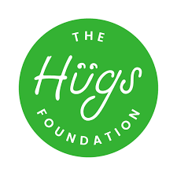](https://www.google.co.uk/imgres?imgurl=https%3A%2F%2Fhugsfoundation.org.uk%2Fwp-content%2Fuploads%2F2018%2F03%2FThe-Hugs-Foundation-RGB-01.png&imgrefurl=https%3A%2F%2Fhugsfoundation.org.uk%2F&docid=prvl53T9JWcTxM&tbnid=GkLnQAWNx2k-5M%3A&vet=10ahUKEwiRqIrYnOfmAhVinVwKHTSJCfUQMwhDKAAwAA..i&w=597&h=596&bih=967&biw=1920&q=the%20hugs%20foundation&ved=0ahUKEwiRqIrYnOfmAhVinVwKHTSJCfUQMwhDKAAwAA&iact=mrc&uact=8)

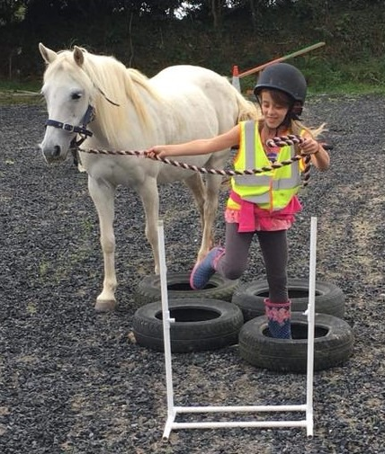

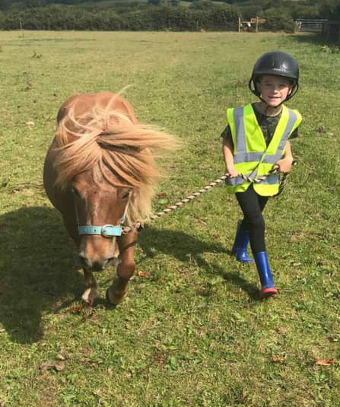

**February Half Term Holidays Activities**

**Pony Fun Day**

Monday 17th February 2020

10.00am – 14.00pm £30 per person

Come and have a day filled with fun and learn what it is like to look after your own pony.

**∙ Meet the animals ∙ Horse care ∙ Stable management ∙ Equine quizzes ∙ Craft making activities ∙ Take part in your very own in hand horse show**

Booking essential as places are limited and any cancellations made with less than 48 hours’ notice will require full payment, sadly we will not be able to refill your place.

Suitable outdoor footwear and appropriate warm waterproof clothes are essential. Please remember to bring a packed lunch, snacks and a drink.

To book your place please ring **07948404986** or email [**nicki@hugsfoundation.org.uk**](mailto:nicki@hugsfoundation.org.uk)

Quote code **Pony04** for a prize on the day.

**The Hugs Foundation, Higher Whitley Farm, Helland Road, Bodmin, PL31 2NT.**

[**www.hugsfoundation.org.uk**](http://www.hugsfoundation.org.uk)

