Mentoring, coaching and leadership recognition framework
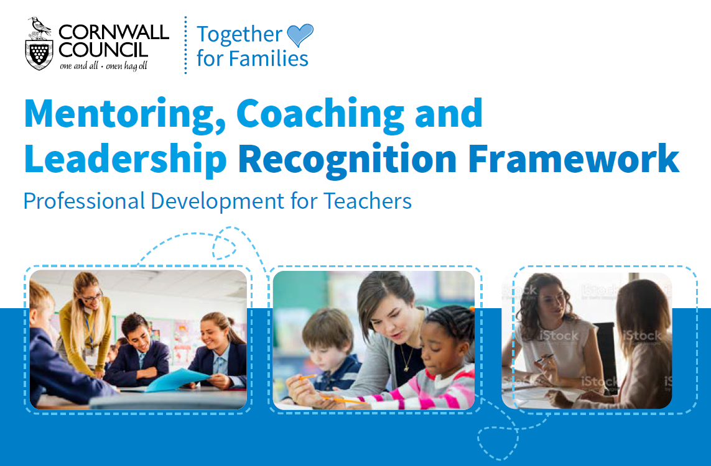

Overview
“Coaching used as a process to unlock potential; can improve work performance, life experience, self-directed learning, and personal growth”(Grant 2000).
The school effectiveness team at Cornwall Council has developed a Mentoring, coaching and leadership recognition framework. This evidence informed Framework has been designed to support the lifelong learning model from trainee teacher, through to middle, senior and executive leadership and to support the development of a collaborative learning community within our schools underpinned by mentoring and coaching.

The Mentoring, coaching and leadership recognition framework has three phases: -
- An Effective Mentor – Phase 1 is the standard requirement for all mentors working with teachers.
- An Advanced Mentor and Coach – Phase 2 is a professional who has considerable experience in mentoring and/ or coaching who can demonstrate impact on their own and others professional practice.
- A Master Mentor and Coach – Phase 3 is a professional who has engaged in leading both mentoring and coaching who can demonstrate impact within a school, organisation or across organisations.
These phases are progressive, building on the development of key characteristics, skills, and processes, but teachers can start at the phase that meets their current level of experience.
Supporting a professional development programme
School leaders can use the framework to support the implementation of a mentoring and coaching programme that will support the professional development of their staff.
“As a school we have seen huge benefits of using the mentoring, coaching and leadership framework as part of our professional development programme. We have found that the coaching and mentoring programme has built authentic trust between our staff, and we have fostered a learner-centered school environment where there is a real culture and ethos of staff reflection to ensure improvements for our children.
“It’s the first time in my teaching career that I have sat down with a group of colleagues, engaged in a professional dialogue about my own practice but also the practice of others, and where we have all worked together to identify strengths and next steps going forward. The best form of professional development we could ever be offered!”
The offer
The Recognition Framework and accompanying package of support is available through service for schools https://schools.cornwall.gov.uk/ at a cost of £250 which includes: -
- Two half day training sessions on mentoring and coaching for a minimum of three staff.
- Access and support in completing the Recognition Framework.
- Two follow up meetings to support the planning and implementation of a mentoring and coaching programme.
Recognition Certificate: For an additional £100 schools can purchase a quality assurance visit to award staff who have successfully completed the process a Certificate of Recognition.

For further information please contact: -
Nicky Hepworth | School Effectiveness Advisor (Curriculum)
Nicky.hepworth@cornwall.gov.uk | Mob: 07547671037

