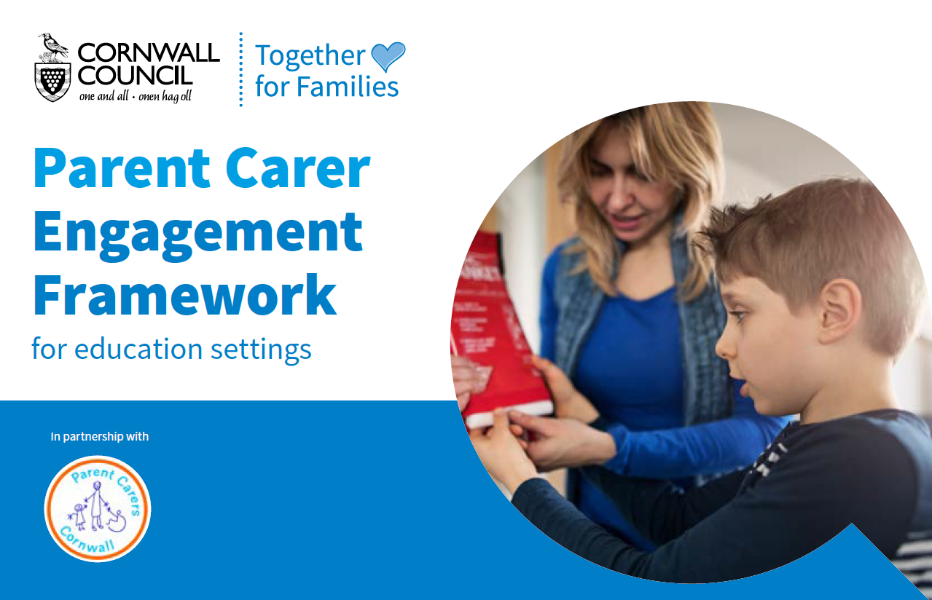
Overview
Effective parental engagement is a crucial ingredient in both academic and social success, especially for our most vulnerable pupils. Cornwall Council’s Together for Families Directorate, supported by Parent Carer Cornwall, have developed a framework and toolkit to promote the partnership between pupils, parents, and school to help create a culture of mutual collaboration to support all learners to succeed.

The Framework
This resource is designed to be a working document that supports education settings in the development of a parent carer engagement strategy and to be central to the work they do to raise aspirations and achievement. The resource includes: -
- A framework based on principles and criteria for building the education setting’s approach, structured around seven themes.
- Descriptors for what all education settings should be doing as well as what successful schools do – aiming to provide a direction of travel for future work.
- A ‘selection box’ of practical resources and references that education settings can select from to support meeting the identified principles.

Customer feedback
“In the dedicated work around parental engagement, the Framework has shone a much-needed light on fundamental components of home/school relations which can be too easily overlooked. In championing the application of the framework and through engaging in school-level discussions around individual contexts, the Framework has supported us to reflect and further develop the way in which we work with our parents, particularly those most at risk of marginalisation” (Penpol School).

“The Parental Engagement Framework has provided us with a structured approach to more effectively identify strengths and gaps within the work we already do with parents. Subsequently, we now have a precise focus for how we want to be best continue engaging parents with their child's learning and we're implementing evidence-informed action to do so. The Framework has supported our school to avoid that 'scattergun' approach. We're looking forward to seeing the impact of the work our school community has collectively undertaken to increase parental engagement” (St Day and Carharrack School).

The offer
Education settings can access the Framework through services for schools https://schools.cornwall.gov.uk/ for £300 and the opportunity to participate in a two-year programme.
- The first year is the foundation year where education settings can work with a member of the school effectiveness to support the action planning and delivery phase of the programme. There is also an opportunity to purchase a one-off training session for staff to support a whole school approach to parental engagement for an additional cost of £100.
- In the second year of the programme schools produce a case study that demonstrates evidence of impact of the parental engagement work. Through a quality assurance visit from school effectiveness (additional cost of £100) and ratification of the case study a Certificate of Recognition is awarded if the parental engagement principles have been met.

For further information please contact: -
Nicky Hepworth | School Effectiveness Advisor (Curriculum)
Nicky.hepworth@cornwall.gov.uk | Mob: 07547671037

