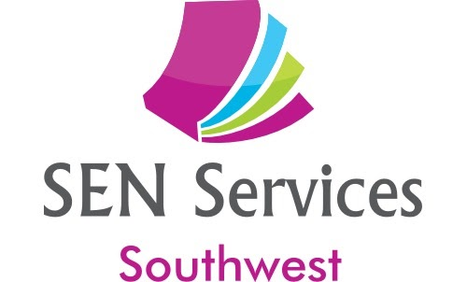

email: senservicessw@gmail.com

Tracey Foster BSc (Hons), PGCE, MBPsS
Mob: 07913 179125
Sue Plechowicz BSc (Hons), PGCE, MBPsS
Mob: 07854 110297
www.senservicessw.com

An Introduction to the Role of Teaching Assistant in a Mainstream Setting

This is a five-part course - Each part can be accessed via the live zoom session on the dates below or as a recorded zoom session (or a mixture of the two)

Monday 11th, 18th, 25th September and 2nd , 9th October 2023
1:30pm – 3:30pm

Total cost for four sessions - £125
(Reductions available for more than one person from the same school)

Training for those who are new to the Teaching Assistant/Inclusion Support role in Primary or Secondary schools

Attendees will gain:
- A knowledge of initial strategies for supporting learning in the classroom
- The importance of relationship-building
- An understanding of how to support children with specific learning needs
- An understanding and strategies to support behaviours that challenge in the classroom
- How to run effective small group or 1:1 interventions successfully.

Testimonials for our courses:

'Thank you, thank you, thank you for this amazing course! Your knowledge is incredible and I'm excited to begin . Jo Morris, SENCo, Great Kimble C of E School, Bucks

“This course provided “off-the-peg” materials and ideas which I can implement immediately.” Gareth Herring, Teaching Assistant, Penryn College, Cornwall

To book, email us at senservicessw@gmail.com or call Tracey on 07913179125 or Sue on 07854110297

