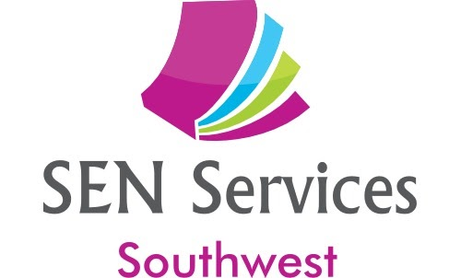

email: [senservicessw@gmail.com](mailto:senservicessw@gmail.com)

Tracey Foster BSc (Hons), PGCE, MBPsS

Mob: 07913 179125

Sue Plechowicz BSc (Hons), PGCE, MBPsS

Mob: 07854 110297

www.senservicessw.com

# Planning Your Year as SENCO

# inc how to meet OfSTED requirements

**Thursday 22nd; 29thth September and 6th October 2022**

**3:30 pm – 5:30pm.**

**You will need to attend all three sessions.**

## 

**Total cost for three sessions - £75 (invoiced on booking)**

Training for colleagues new to the SENCo role in Primary and Secondary schools as well as those wanting an update on how the SEN Code of Practice affects the day-to-day role of SENCo

This course is an online delivery, via zoom, of our extremely popular course.

Run by highly experienced primary/secondary SENCos, who have an in-depth knowledge of all areas of Special Educational Needs, as well as tried and tested methods for managing your time effectively and ensuring that the provision in your school is at its best.

### Attendees will gain:

### Understanding of how to write an effective SEN Action Plan for 2022/23

* A clear understanding of the SEN Code of Practice 2015 and your responsibilities as a SENCo.
* Templates for the Assess, Plan, Do, Review cycle
* Strategies for planning interventions and measuring their impact
* Ideas for effective monitoring of progress

### ****'Thank you, thank you, thank you for this amazing course! Your knowledge is incredible and I'm excited to begin an overhaul of our current SEND provision in line with your suggestions... they have made a world of difference to my wellbeing!'  Jo Morris, SENCo, Great Kimble C of E School, Bucks****

### To book, email us at [senservicessw@gmail.com](mailto:senservicessw@gmail.com) or call Tracey on 07913179125 or Sue on 07854110297