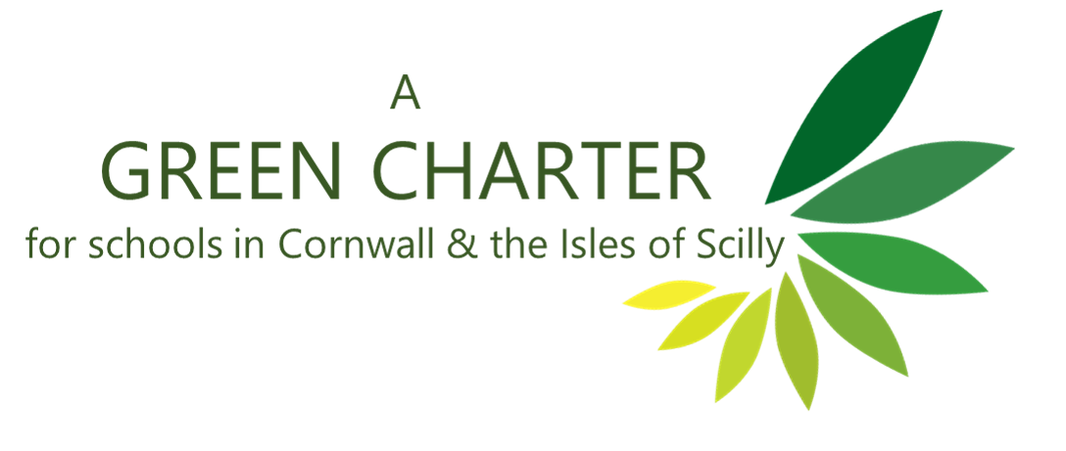

As educators, we are committed to teach our young people to be environmentally literate and to develop their knowledge, skills, motivation and confidence to practice and promote sustainability in their community.

As organisations, we are committed to ensure any decisions we make about our working practice take into account the impact on the environment, with the aim of adopting sustainable practices wherever possible.

To this end, we will:

- Collectively declare a climate emergency in November 2019​​.

- Provide opportunities for staff, Governors, children, and community to find out about the climate emergency and what action they can take. Ensure at least one member of staff has climate change training.

- Gain Eco-School status within two years, then maintain it thereafter.

- Significantly reduce the use of single-use plastic with the aim of becoming ‘plastic free.’

- Develop the school grounds (or other local space) to promote engagement with nature, biodiversity and growing food​. Plant at least 30 trees every year ( eg free Woodland Trust Packs) and ensure they are looked after.

- Have a meat-free school menu once a week​​ and/or promote the benefits of eating less meat and more seasonal, locally-sourced food.

- Speak out. Staff work with pupils to engage with parents and community in order to promote action on climate change.

- Engage with another school (nationally or internationally) about action in schools.

- Support Cornwall Council’s aim to become carbon neutral by:​​
- reducing energy consumption by at least 10%​​
- using some form of renewable energy source on site​​, where possible
- buying energy from renewable suppliers​​, where possible

- Explore ways to lessen the impact of petrol and diesel vehicles on the environment.

