***Understanding Christianity***

This resource supports schools in delivering the new Cornwall RE Agreed Syllabus (2020).

***Understanding Christianity training***

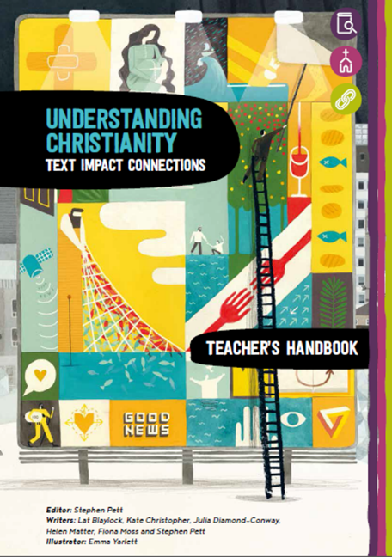

**The Training Package**

To receive this extensive resource pack, schools need to attend training **all the modules.**

Following recommendations from the Centre for Evaluation and Monitoring, and the Teacher Development Trust, effective training should be intense and sustained, the expectation is that teachers in primary schools will have at least 10 hours of CPD on *Understanding Christianity*. There will be gaps between encounters when schools will try out the approach, returning to explore further.

1.http://www.cem.org/attachments/publications/ImprovingEducation2013.pdf

2.http://tdtrust.org/about/dgt and http://tdtrust.org/wp-content/uploads/2015/10/DGT-Full-report.pdf

**The Resource**

Includes:

•a teacher’s **Handbook**

•**22 detailed units of work for primary** –20 of them match the primary units from the Cornwall Agreed Syllabus

•Over 100 pages of **photocopiable resources**

•a **wall frieze** showing the ‘big story’ of the Bible, to back up the units

•**full online access** to the resource –available to use within your school.

Frieze art helps pupils to build a coherent grasp of the key concepts explored in the resource. © Emma Yarlett 2016

|  |  |  |  |  |
| --- | --- | --- | --- | --- |
| Understanding Christianity by RE Today | Wed 3rd March 1.00 – 5.00pm  Wed 5th May 1.00 – 5.00pm  Tues 22nd June 1.00 – 5.00pm | Virtual by Zoom | See cost below | School Leaders, and Teachers |
| **Understanding Christianity gives in-depth support to the Christianity sections of the new Cornwall RE syllabus.**  It aims to develop pupils’ understanding of key concepts in Christianity, as a contribution to their understanding of the world and their own experience within it. This 3-session course will give teachers full access to this outstanding resource and nationally recognised system of learning in RE.  Session 1 – Wednesday 3rd March  Modules 1 and 2 (Introduction and Teaching & Learning)  Sessions 2 – Wednesday 5th May  Modules 3 and 4 (The Big Story of the Bible and Planning great Teaching & Learning)  Session 3 - Tuesday 22nd June  Modules 5,6 and 7 (Purpose & Impact, Digging Deeper, Curriculum Design)  • Each session will include setting teachers a ‘gap task’, trialling an aspect of the resource in school.  • Feedback and discussion on these ‘gap tasks’ will be included in each session, so that teachers can share ideas and learn from each other’s experiences.  ***Places are limited to 30 school places***  *Community schools £20 (inc. folder) with subsidy C of E schools £20 (exc. folder)* | | | | |

Accredited trainers: Nicki Bonell and Felicity Henchley (LTLRE West and Mid Cornwall primary hub leads)

**Booking form and further details attached.**

**Please send booking form to XXXXXXXXX**

**or RE Today, 5-6 Imperial Court, 12 Sovereign Road, Birmingham, B30 3FH**

**T: 0121 458 3313|F: 0121 285 1816**

Training will be led by **Nicki Bonell and Felicity Henchley**, both LTLRE primary Hub leads for West and Mid Cornwall who will be able to share the practicalities of delivering Understanding Christianity in the classroom.

**To book your place, please click** [**here**](https://bookwhen.com/trurodiocese/e/ev-s4af-20210303130000)