Modern Slavery – Closer than you think!
An Awareness Training Session for frontline professionals

Date: 4th December 2019 Time: 08:45
Venue: Cornwall Council, Council Chamber, County Hall, Treyew Road, Truro, TR1 3AY

Telephone: 0300 1234 100
www.cornwall.gov.uk

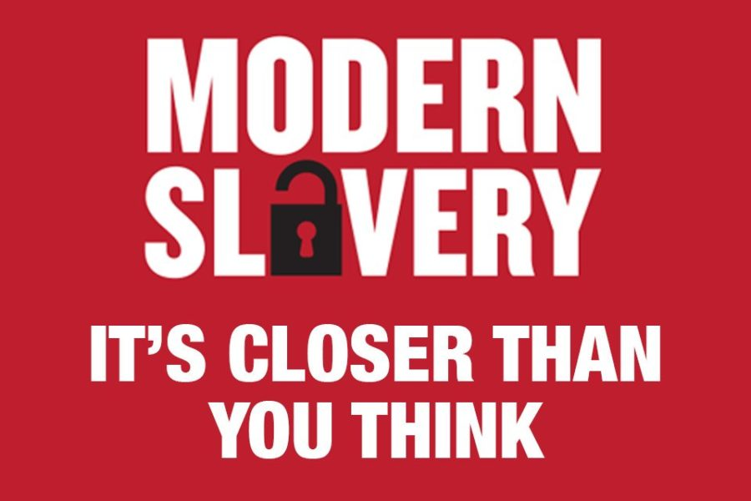
Background

The well-dressed couple at Truro railway station decline to take a leaflet from The Salvation Army volunteer raising awareness about modern slavery. “No thank you,” they say. “Slavery doesn’t happen here. Not where we live.”

The truth is different. Slavery is everywhere – today, across modern Britain, in backstreets and upmarket suburbs alike. It is likely that the same couple encounter the victims of this appalling crime every day, without realising it. Slaves are working in nail bars, car washes, cutting and planting on farms, as domestic help, in factories, in the catering industry – and all too often remain invisible to those whose attitude is: “not where we live”.

That couple might be dining out at a smart restaurant where the potatoes on their plates were picked by men who earn little or nothing, often bound by a “debt” to their trafficker, and sleep in groups in freezing shipping containers or old caravans. The debt that slavers impose on victims is often excessive and impossible to pay when the
worker’s wage is pitiful or even non-existent.
Our couple’s glasses may have been washed by a vulnerable young woman whose manager gives her leftovers from customers’ plates but no money. Their taxi home may have just dropped off men at an upmarket pop up brothel offering British girls for sale.

Sound far-fetched? “Sadly, it’s not,”
The Safer Cornwall Serious Organised Crime Operational Group know that this goes on across Cornwall and are taking steps to tackle this crime at all levels

Steve Rowell the Serious Organised Crime Operational Lead Cornwall said “It’s often worse than the scene painted. The girl in the nail bar could be exploited into the sex trade. The men picking potatoes could be told their families will be harmed if they try to escape. The threats faced by victims are endless, the depth of their degradation is bottomless. The list of jobs they do is only as limited as your imagination.”

Modern-day slaves wear no labels but the guise of sex workers, child pickpockets, domestic helpers, caterers, masseurs, tarmac layers, farm labourers, car washers and factory staff. They all carry a price tag and are bought and sold, used and abused.

Slavery stretches right across the county and seeps into affluent and poor areas, involves foreign nationals and Britons, and affects men, women and children. It is as rife in rural areas as inner cities. It is right here, right now. The National Crime Agency reports that a total of 6,900 people, (40% of which were children) were potential victims of modern day slavery for exploitation in 2018, an increase of 450% in last 4 years
This figure does not reflect the true picture of modern slavery, we estimate that there are over 13,000 people who we suspect are trapped in slavery and trafficking, in the UK.
What is certain is that the figures are rising.

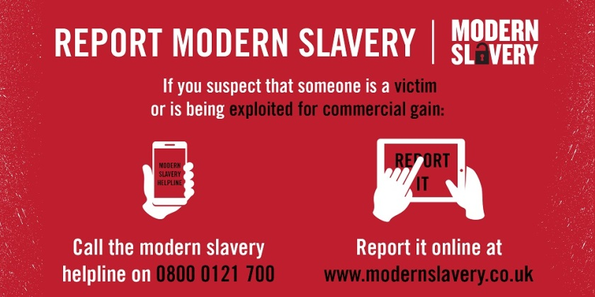

In Cornwall we have already had large scale operations to help victims of modern day slavery, with one case alone identifying 14 victims on a West Cornwall farm.

So why are we in the UK, this civilised nation proud of its freedom and democracy, so unaware of modern slavery? We might choose to ignore it, It’s a cliché, but British people like to mind their own business and we don’t poke our noses into our neighbours’ homes. We prefer to think of slavery as something that exists only in history and films. It’s time to face painful truths and poke our noses further.”

The Modern Slavery Act 2015, the first of its kind in Europe, makes prosecuting slave-drivers easier, ensure sentences for the organised criminal perpetrators are tougher and keep victims safer.

Work across the county is progressive utilising non-legislative and legal support to protect victims, and disrupt and prosecute perpetrators. Through the Cornwall Serious Organised Crime Operational Group, so much work is being done on the ground. This now involves for example a greater awareness with training being rolled out to statutory, voluntary and community sectors, multi-agency operational visits and enforcement which includes Cornwall Council Services, Devon and Cornwall Police, Gang Licencing Abuse Authority, HRMC, Border Force, and many NGOs who are alert to the signs. Trading standards are identifying victims because people are alerting them to badly paved drives. But we need more awareness. It’s not that people are choosing to ignore modern slavery, but they don’t know what to look for.

In Cornwall, during the summer of 2016 we were made aware of 14 pop up brothels in the Newquay area. When investigations were made afterwards, members of the public suspected that something was untoward but didn’t recognise the signs.
Neighbours noticed frequent male callers all hours of the day, but didn’t think such a thing would be happening in their own street.
That’s what slavery looks like. And unless we make it our problem, this kind of crime will continue.”

In Cornwall we want everyone to recognise the signs to prevent exploitation and trafficking. For this reason Safer Cornwall in conjunction with Cornwall Council Resilience & Emergency Management are providing a face to face Modern Slavery Awareness session to front line staff from all sectors of the community in the hope that word of mouth helps earlier detection and supports intelligence gathering for enforcement and disruption activity.
Being vigilant when it comes to modern slavery means opening our eyes to what is under our nose. Ask yourself, why is one company’s block paving so drastically cheaper than the rest? Think about the gardeners whose rates were so reasonable – did their workers look well-fed and have any breaks? And why does the nanny next door work seven days a week and never talk to anyone at the school gates? Be alert and suspicious when you are concerned something isn’t right.

“Modern slavery is hidden in plain sight. We must recognise it, report it and be part of a movement to give victims not only the treatment they deserve, but also hope and freedom.”

Contact

If you require any further details about this training session, please contact:
Name: Steve Rowell MICJP
Preventing Extremism/Terrorism Lead Cornwall and Serious Organised Crime Operational Lead Cornwall
Email: steve.rowell@cornwall.gov.uk
Mobile: 07980895104

Or

Claire Penellum DipHEP MEPS| Resilience Officer
Cornwall Council | Resilience & Emergency Management
Resilient Cornwall, Neighbourhoods Directorate
Claire.penellum@cornwall.gov.uk
Tel: 01872 326996 | Mobile: 07817 877273

