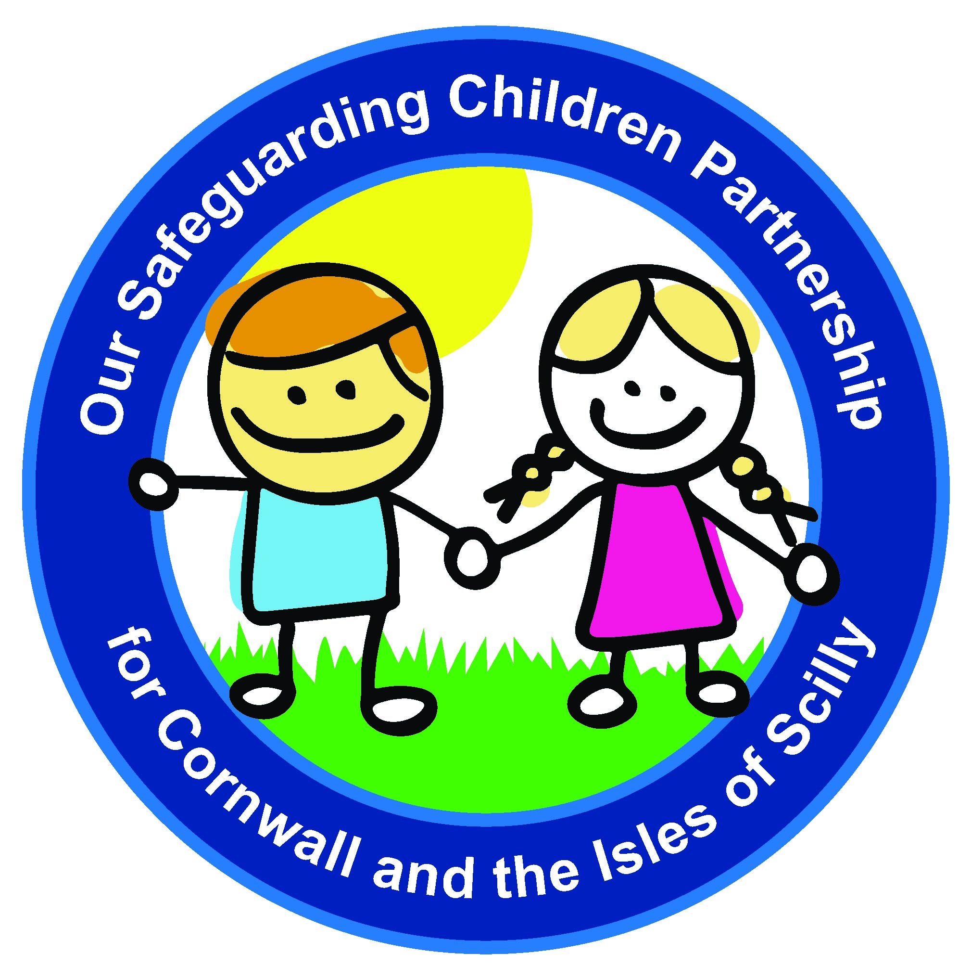
Our Safeguarding Children Partnership
for Cornwall and the Isles of Scilly

Vulnerable Adolescents Strategy Consultation

From: | Name | Agency

Page Number | Comments

Please return this form to Frances James, Safeguarding Administrator – frances.james@cornwall.gov.uk
by 30 September 2019

