ASONE Perform CIC
St Merryn Airfield
St Merryn
Padstow
PL28 8PU
hub@asoneperform.com

JUN 19th, 2023

To whom it may concern

To prepare the ground for introducing the five strategic functions for Music Hub lead organisations that include:

Partnership:
- Take a leading role in building a sustainable, local infrastructure for high-quality music education and music-making, in partnership with schools, early years and other education providers, community organisations, and other regional and national youth music organisations and industry. Capture this offer in a Local Plan for Music Education.
Schools:
- Support all state funded schools in their area through ongoing relationships to help them deliver high-quality music education. This should include a quality curriculum support offer, specialist tuition, instruments and ensembles; and a broad range of progression routes and musical experiences for all pupils.
Progression and Musical Development:
- Support children and young people to develop and progress with music; including into national or specialist opportunities, higher education and employment, so that the chance to be involved in high-quality music making is shared more widely in our society. Support children and young people to access the wider world of music including live performance and community music.
Inclusion:
- Drive broad access to music education, so every child has the opportunity to participate irrespective of their circumstances, background, where they live, or their SEND.
Sustainability:
- Ensure the strategic, financial, and operational sustainability of the Music Hub by (i) supporting a dynamic and well trained workforce; (ii) leveraging DfE funding to develop wider investment into young people's music from a range of sources and revenue streams; (iii) being accountable and transparent by publishing plans, needs analysis and impact data; (iv) considering and acting on the Hub's environmental responsibilities.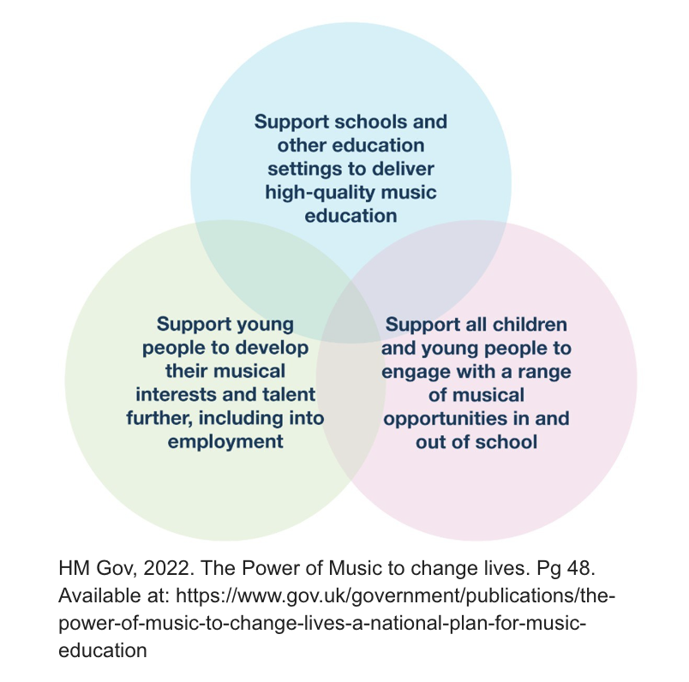
After a year of continuous improvement to prepare the ground for the new administrative process and approach. The restructure of ASONE Hub was finally triggered by a culture of:
- Unsustainable working practices that where present int the inherited job roles.
- Unnecessary hierarchical management structure and pay scale.
- There was little or no accountability as all roles were working across all areas.
- A high number of administrative tasks/outputs and event production/management was entangled into and across all roles making it very difficult to encourage/support continuous improvement.
- Smart contracts/agreements were not in place for internal delivery or prescribed into job toles.
- There was little or no transparency in the tendering process.
When looking across the national programme on how other Music Hubs are managed. It was clear that there is no single (transferable) approach and many Music Hubs are still to complete the restructuring process that ASONE Hub have just bridged.

We gleaned best practice from the following Music Hubs:
- ASONE Hub: Existing best practice across quality/delivery
- Birmingham: Tendering and communications
- Brighton and Hove: Managing Partners
- Bristol Beacon: Programme Management

In brief the new/restructured roles are:

Role | hr’s | Rationale | Delivers
Programme Director  To oversee the strategic delivery of the ASONE Hub including, setting the vision and direction (as described in the National Plan for Music), effective management of projects , delivery of Department of Education (DfE) through the Arts Council England (ACE) agenda by developing links with key stakeholders and partners. Ensuring integrity and coherence across ASONE Hub activities and maximising the delivery and accessibility of Music Education to Young people in Cornwall. Contribute to data capture for statutory reporting. | PT .6 | At least 70% of the activity within this role was not prescribed to the job spec that we inherited.  By removing the other areas of delivery there is space to allow the role to bed in and use the remain .4 later (increase to full time) with clear strategic focus and fundraising capacity.. | Programme Curation Direction  Strategic Relationship Management  Funding and Applications
Programme Administrator  To support the delivery of the ASONE Hub strategy by providing administrative support to the Programme Director, and Consortium to deliver the Arts Council England (ACE) agendas and other ASONE Hub activities to maximise the delivery and accessibility of Music Education to Young people in Cornwall. You will contribute to data capture for statutory reporting. | FT | This is key role in ensuring ASONE Hub operates within its DfE/ACE contractual agreement, delivers correct and meaningful data and subsequent reporting to the consortium members and funders. | Monitoring delivery against KPI’s  Data Collection and Translation  Programme Administration  Project Reporting
Office/Contracts Administrator  To prepare ASONE Hub contracts and tenders as required. This will include managing third party contracts related to statutory delivery (including subsidies), utilities, accommodations, services & consultancy. Seeking efficiencies and high-quality solutions which are fit for purpose. To respond manage and facilitate resource requests within budgetary constraints. To contribute to data capture for statutory reporting. | FT | This is reshaped role as ASONE will employ an Operations Director that will manage the strategic aspect of this job including procurement (over 10K) and asset management, investment decisions.  Also this role is being focussed by removing the everyday financial accounting. | Office and Contract Management  Internal information systems and liaison/actions with/across HR
Community Engagement Administrator  As the ASONE Community Hub administrator and moderator the role will proactively facilitate positive communication, active engagement and build relationships with all consortium members through the ASONE Community Hub (website). You will disseminate and release information as it relates to the ASONE Hub Programme and business plan and contribute to data capture for statutory reporting. Receiving information from the Events Admin and Front of House Lead to generate tickets, content & events listings. | PT.6 | This is a simplified job spec (compared to the previous multi-tasking role) with a focus on encouraging and moderating engagement on the community platform. It will have specific and smart target and act as first point of access the ASONE Hub.  It will also ensure ongoing communication with the consortium members is consistent and relevant. | Point of contact for all enquires.  Digital/Media Asset Management  Schools (first access) Liaison  Document management and Tender Application Administration
Events Administrator (FOH)  To work as part of the growing ASONE events team and lead on event administration for Front of House (FOH) for live performance events from brief to execution. Collating all information as it relates to ticketing and audience experience and corresponding with the Community Engagement Administrator to provide content that generates events listings and deliver post event audience evaluation. You will be responsible for the delivery of best results, on time and on budget, while working collaboratively and efficiently with the ASONE Hub consortium. | PT.4 | ASONE Hub delivers over 30 events a year and yet no previous role had ‘events’ as part of their main job spec.  Having hired a production role at .2 it became clear that the audience facing role needed to be defined and stood alone.  Again this role is created with room to grow and the events programme (outside of the DfE statutory delivery for access to cultural event opportunities) will increase and the other .6 of this role, will be funded by other income. | Front of house  Artist Liaison  Ticketing  Press and PR  Surveys and audience Feedback  Social media at Live Events

The other roles within the are unaffected by the restructure but will be issued with new contracts to reflect a change in terms and conditions and a recent pay rise.

These roles are:
- Warehouse and Instrument Manager
- Warehouse and Instrument Technician
- Event Production Lead

There Restructure does create a measure of risk and during the process of introducing the restructure the current Programme Director resigned and two further roles have been placed at risk.

To mitigate this risk we have an interim Programme Director already in post completing a detailed handover who has been working with the Cornwall Music Hub for four years.

We have also put in place and interim Programme Administrator to manage the immanent data return and provide the subsequent data for the new application.

Please feel free to contact us for further information.

Cindy Dalgleish

Managing Director
ASONE Perform CIC
cindy@asoneperform.com

Signature:

Date: 19th June 2023

