Social Media Comms Plan for NHS Devon
The username to be tagged in captions needs to be adjusted according to the social media platform.
- Facebook: Stop It Now! UK and Ireland
- X (Twitter): @Lucy_Faithfull_
- LinkedIn: Lucy Faithfull Foundation
- Instagram: @lucyfaithfullfoundation

Week One | Caption | Resource (Facebook/X (Twitter)/LinkedIn | Resource (Instagram) | Audience
Launch  Post | We are delighted to be partnering with @Lucy_Faithfull_ for their #StopItNow campaign to deter online child sexual abuse in Devon and Cornwall.  For more: www.stopitnow.org.uk
1 | Throughout March, we are delighted to be partnering with @Lucy_Faithfull_ for their campaign to deter online child sexual abuse in Devon and Cornwall.  For concerns about child sexual abuse prevention, visit: www.stopitnow.org.uk  #StopItNow | 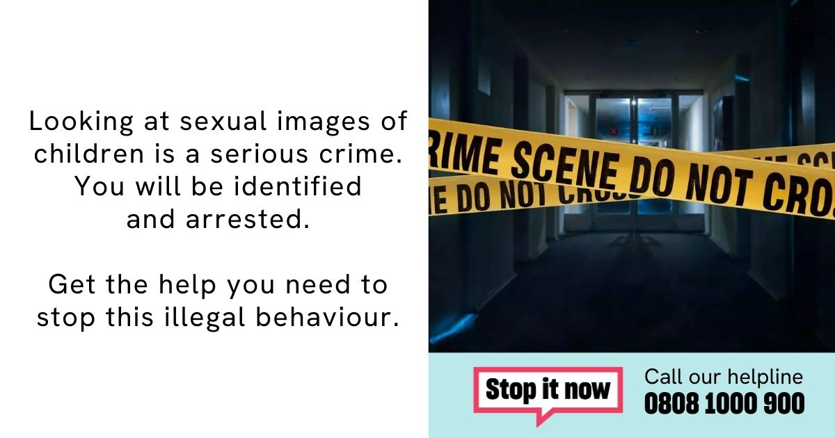 | 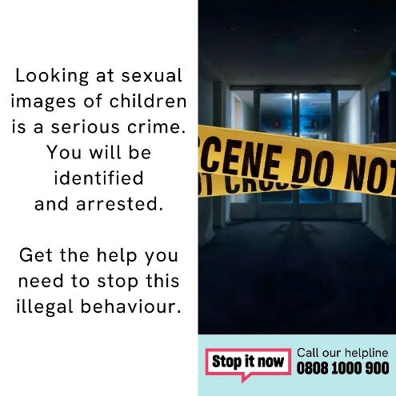 | Offenders/  at risk of offending
2 | Are you in Devon and Cornwall and concerned that a friend or family member is viewing sexual images of children online?  Contact @Lucy_Faithfull_'s Stop It Now for help and support: www.stopitnow.org.uk  #StopItNow | THE WIFE  "V:\Non-Confidential\DETERRENCE CAMPAIGN\IIOC videos\The Wife\IIOC_WIFE_30_Sec_16x9_E1 01.13.21_SUBS.mp4" |  | Family and Friends
3 | Are you a parent or carer in Devon and Cornwall concerned that a young person you know is viewing sexual images of children online?  Contact @Lucy_Faithfull_'s Stop It Now for help and support: www.stopitnow.org.uk  #StopItNow | 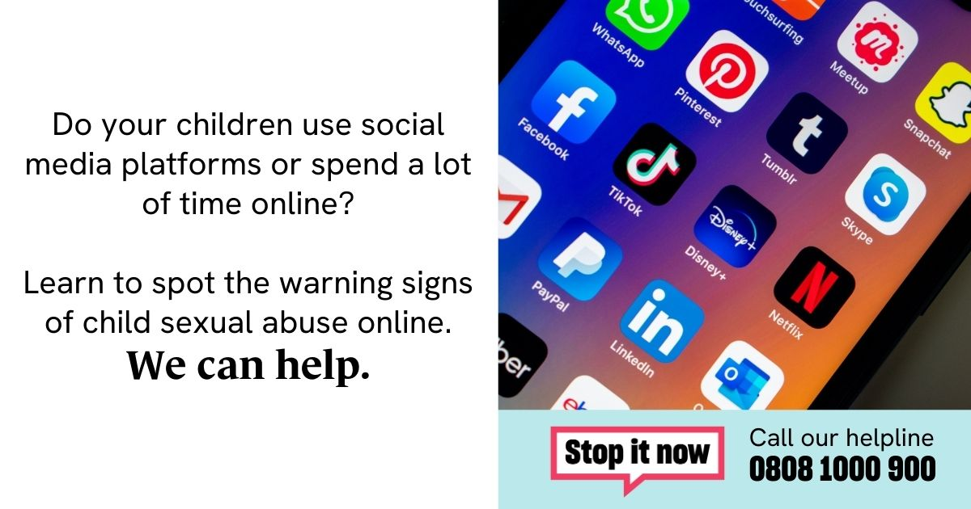 | 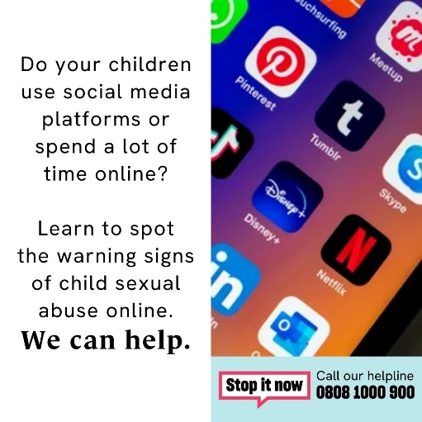 | Parents
4 | Viewing sexual images of children is dangerous, illegal and there are serious consequences. But there is help to stop.  Visit www.stopitnow.org.uk for advice and support/  #StopItNow | 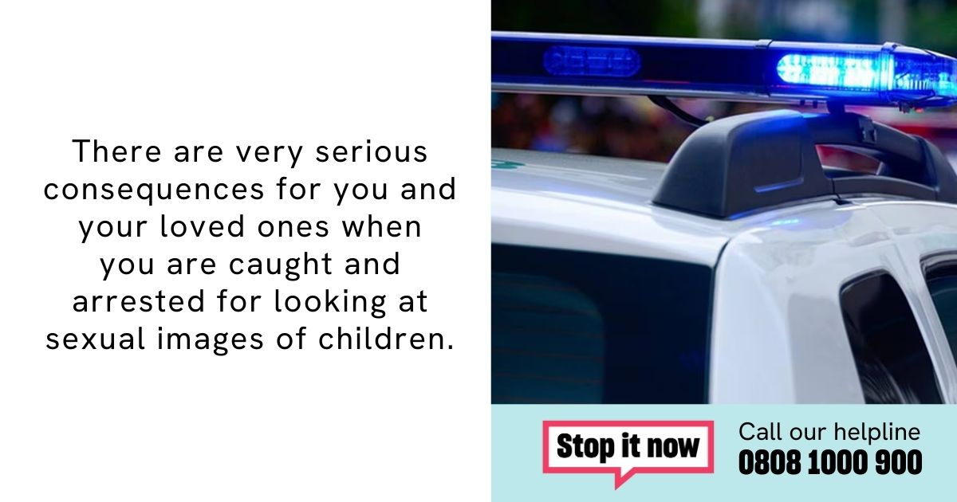 |  | Offenders/At risk
5 | Last year, more than 13,000 people in the South West contacted the #StopItNow helpline with concerns about sexual thoughts or behaviour towards children.  If you need advice and support visit @Lucy_Faithfull_'s Stop It Now: www.stopitnow.org.uk | 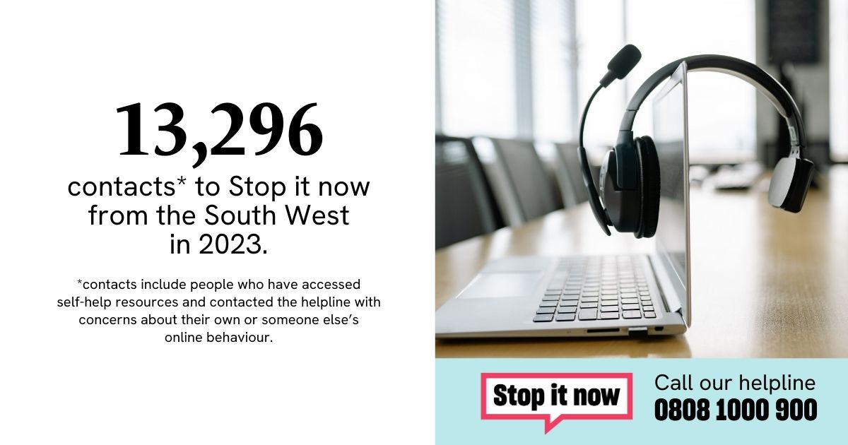 | 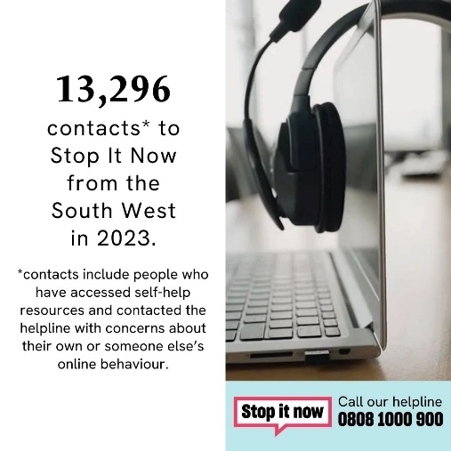 | Professionals
Week Two
1 | Viewing sexual images of children online is dangerous, and illegal. There are serious consequences.  But, there is help to stop via @Lucy_Faithfull_'s Stop It Now: www.stopitnow.org.uk  #StopItNow | 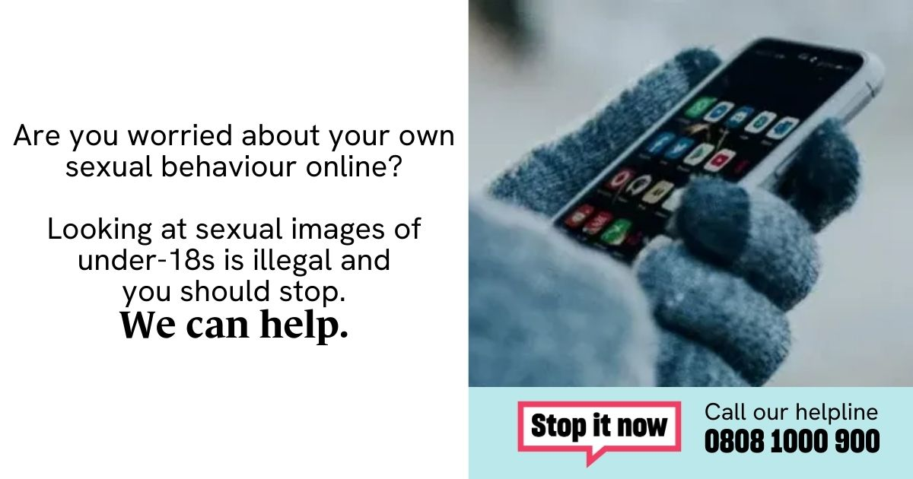 | 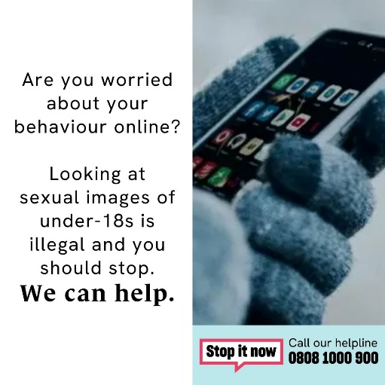 | Offenders/at risk of offending
2 | If you’re concerned that a friend or family member is viewing sexual images of children, help is available.  For confidential advice and support, visit @Lucy_Faithfull_'s Stop It Now: www.stopitnow.org.uk  #StopItNow | 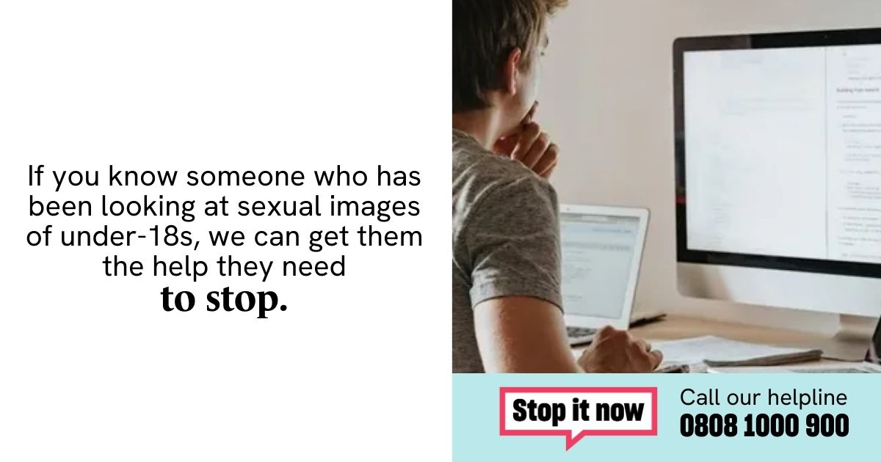 | 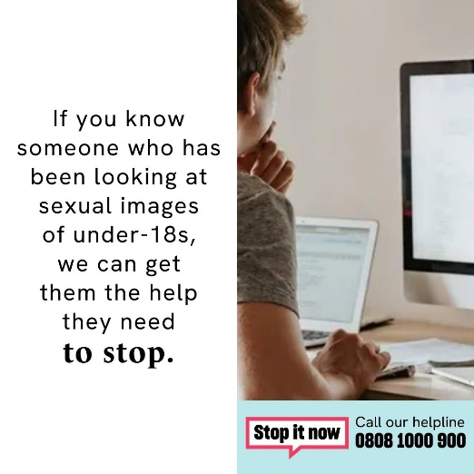 | Family and Friends
3 | Are you a parent or carer in Devon and Cornwall with concerns about a child’s sexual thoughts or behaviour?  Visit www.stopitnow.org.uk from @Lucy_Faithfull_ for confidential advice and support.  #StopItNow | 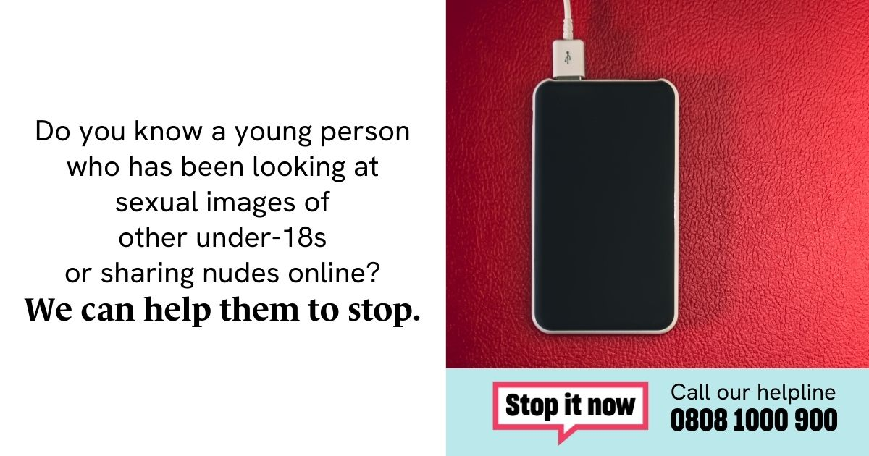 | 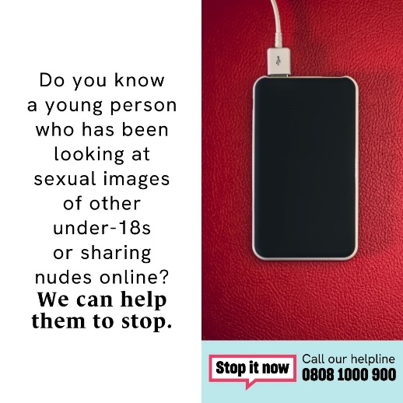 | Parents
4 | If you’re a young person with concerns about sexual thoughts or behaviour, visit www.stopitnow.org.uk from @Lucy_Faithfull_ for confidential advice and support.  #StopItNow | HOUSEMATE VIDEO  "V:\Non-Confidential\DETERRENCE CAMPAIGN\IIOC videos\The Housemate\IIOC_HOUSEMATE_30_Sec_16x9_E1 01.13.21_SUBS.mp4" |  | Young People
5 | The #StopItNow helpline from @Lucy_Faithfull_ has supported more than 75,000 people.  If you’re a professional with concerns about someone’s sexual thoughts or behaviour and in need of confidential advice and support, visit: www.stopitnow.org.uk | 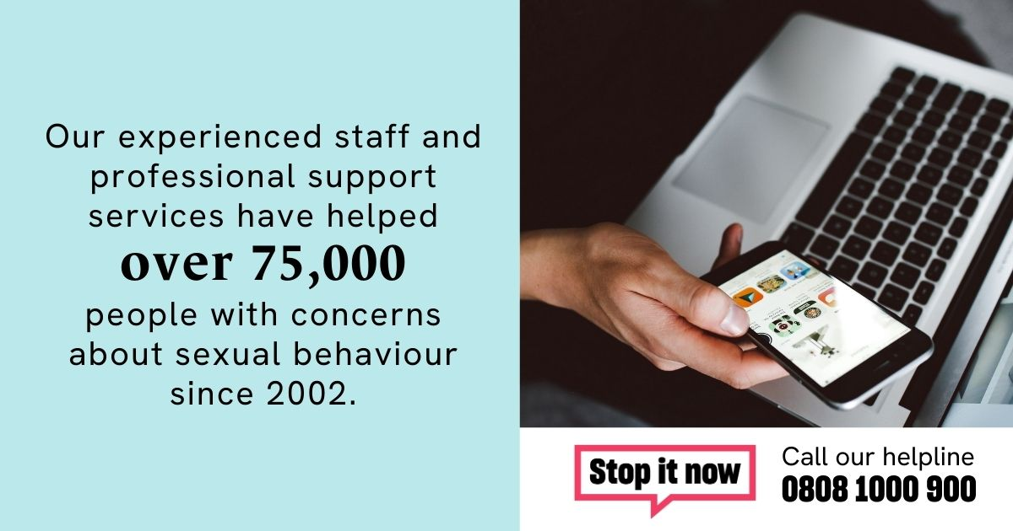 | 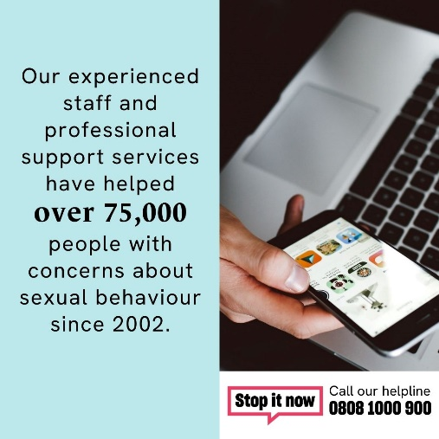 | Professionals
Week Three
1 | Viewing sexual images of children online is dangerous, and illegal. There are serious consequences.  But, there is help to stop via @Lucy_Faithfull_'s Stop It Now: www.stopitnow.org.uk  #StopItNow | THE KNOCK VIDEO  "V:\Non-Confidential\DETERRENCE CAMPAIGN\IIOC videos\The Knock - FlashingImagesWarning\Subs\THE KNOCK - 15' - 16-9_Subs.mp4" |  | Offenders/at risk of offending
2 | Are you concerned that a friend or family member has been viewing sexual images of children online?  Contact Stop It Now from @Lucy_Faithfull_ for advice and support: www.stopitnow.org.uk  #StopItNow | 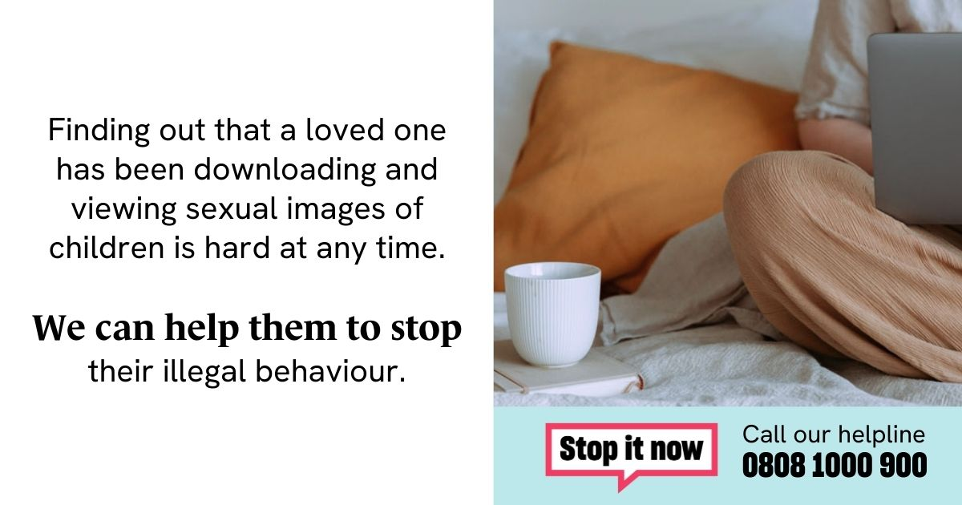 | 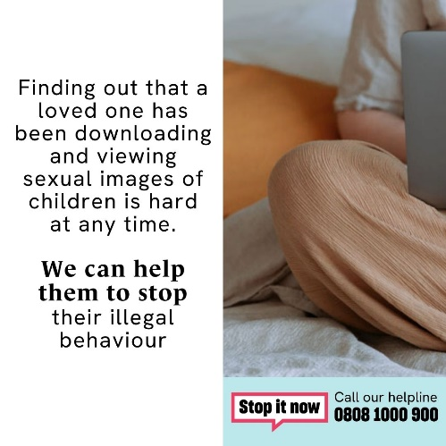 | Family and Friends
3 | Are you a parent with concerns about a young person’s behaviour online?  The #StopItNow helpline provides anonymous and confidential advice and support.  Visit @Lucy_Faithfull_'s www.stopitnow.org.uk for more information. | 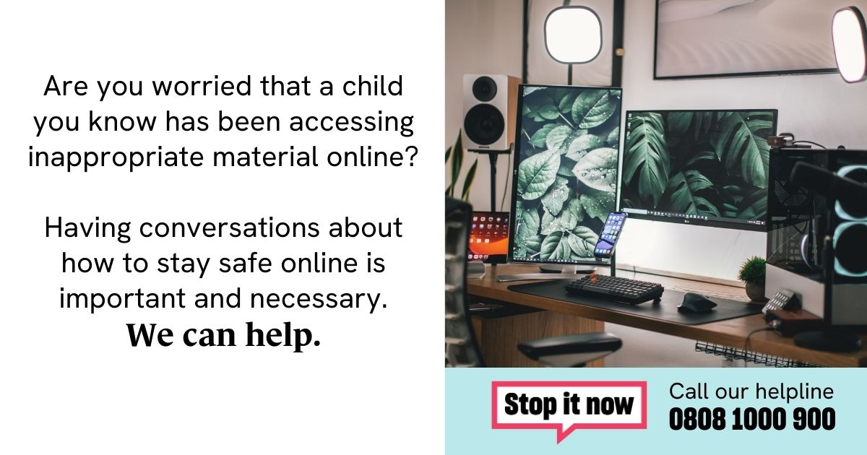 | 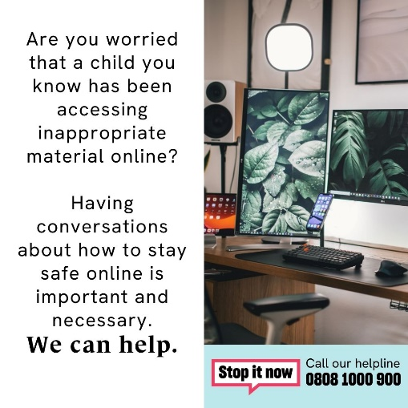 | Parents
4 | If you’re a young person with concerns about sexual thoughts or behaviour, visit @Lucy_Faithfull_'s www.stopitnow.org.uk for advice to stop.  #StopItNow | 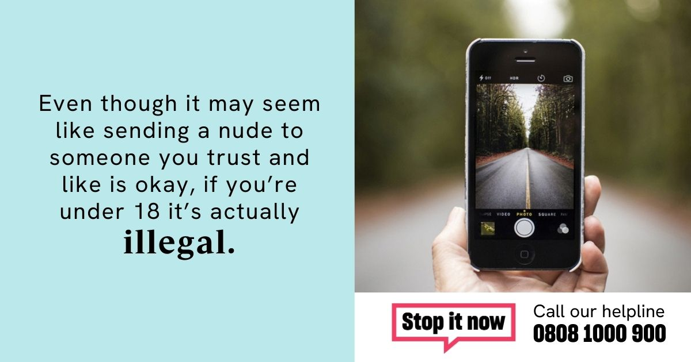 | 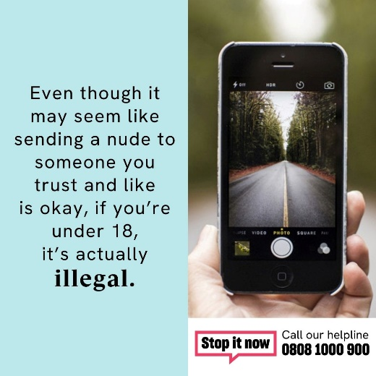 | Young People
5 | Are you a professional with concerns about someone’s sexual thoughts or behaviour towards children?  Visit @Lucy_Faithfull_'s Stop It Now for advice and support: www.stopitnow.org.uk.  #StopItNow | 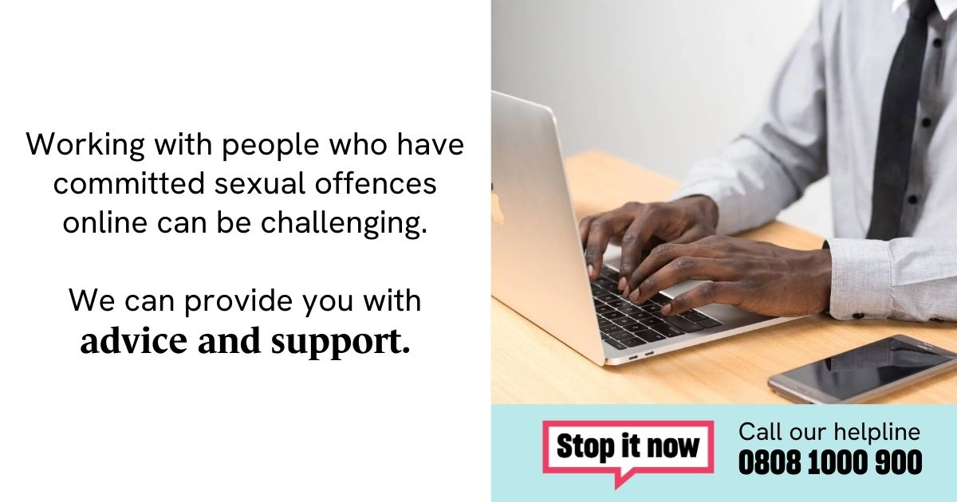 | 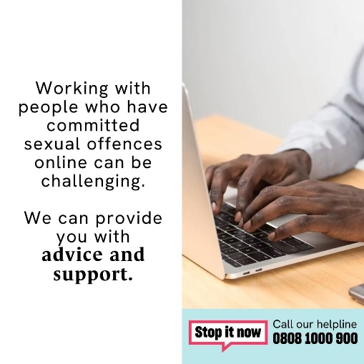 | Professionals
Week Four
1 | If you are viewing sexual images of children online, there are serious consequences including job loss, family breakdown and arrest.  For confidential help and support to stop, visit @Lucy_Faithfull's Stop It Now: www.stopitnow.org.uk  #StopItNow |  |  | Offenders/at risk of offending
2 | Do you know someone who has been looking at sexual images of children?  For confidential help and support, visit @Lucy_Faithfull's Stop It Now: www.stopitnow.org.uk  #StopItNow | TRIGGERS VIDEO  "V:\Non-Confidential\DETERRENCE CAMPAIGN\IIOC videos\Triggers\Triggers\30s\Subs\LFF_30_16x9 Subs.mp4" |  | Family and Friends
3 | If you live in Devon and Cornwall and know someone who has been looking at sexual images of children, we can help.  Visit: www.stopitnow.org.uk from @Lucy_Faithfull_ for confidential help and support.  #StopItNow | 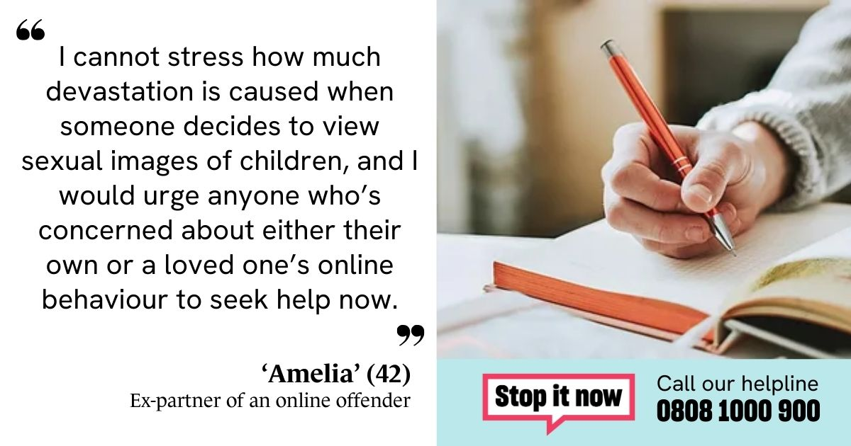 | 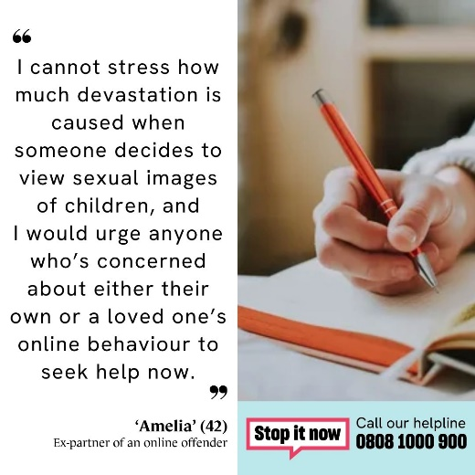 | Parents
4 | This month, we are proud to support @Lucy_Faithfull_’s #StopItNow campaign in Devon and Cornwall.  For more information, visit: www.stopitnow.org.uk |  |  | Offenders/At Risk
5 | We are proud to support @Lucy_Faithfull_’s #StopItNow campaign.  If you’re a professional and you’re concerned about someone's sexual thoughts or behaviour towards children, visit: www.stopitnow.org.uk | 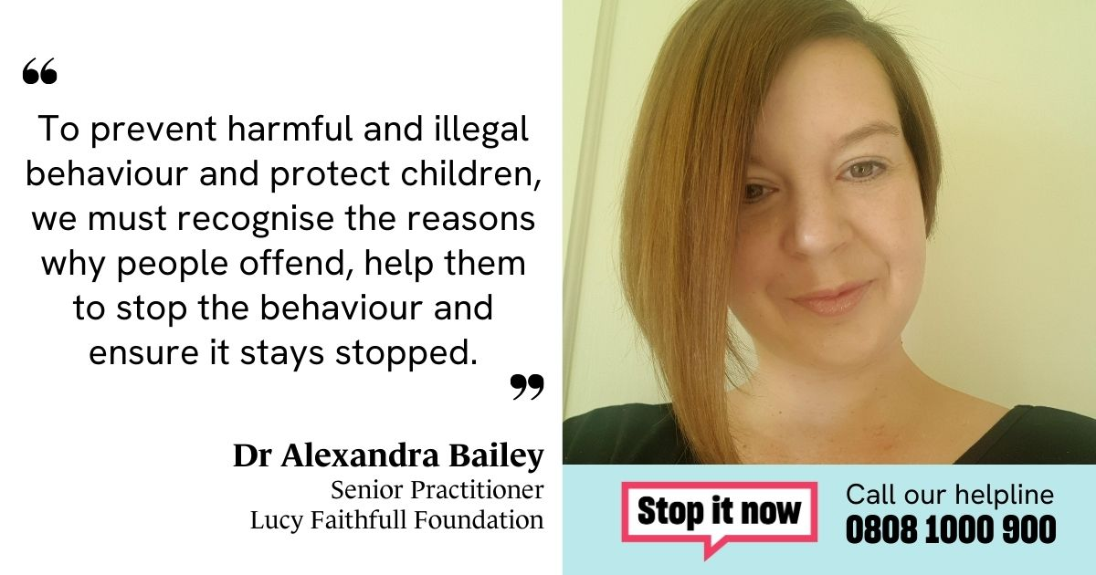 | 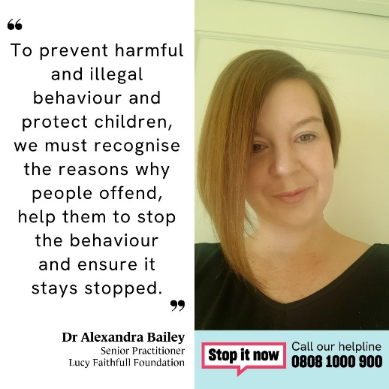 | Professionals

