Suitable for all staff, an ideal way to start the school year as part of whole school INSET or as individual staff CPD
Achieving Mastery with Ian Taylor 
Delivering Great Maths: the Mastery Flow Model

The West Cornwall Teaching School are holding a Maths Conference that looks to launch a special year of Mathematics for this area. This will be led by Mathematics and Numeracy National Leader, Ian Taylor.

Ian is a key player at the Academies Enterprise Trust and has built the mathematics team over the last seven years, attracting highly esteemed colleagues to form an innovative and highly effective team. Ian started teaching in one of the country's most challenging schools based in one of the country's most deprived towns, enjoying success both with achievement and quality of lessons. Whilst Ian was teaching, his lessons were observed by hundreds of colleagues from around the country - including universities, visiting head teacher conferences and research groups to observe outstanding mathematics teaching in what was referred to as England's most challenging school. In 2007, Ian was asked to share his practice around transforming mathematics education for inner city young people in conferences throughout the country. This was the start of Ian's mathematics toolkit. Although he thoroughly enjoyed the position, his ideas took him to a wider role to support mathematics learning across a number of academies. Ian will build on the work on Mastery in Cornwall and is aiming to inspire further great maths teaching through a practical approach that looks at current research throughout the world, including Shanghai, and embraces the philosophy of the Cornwall and West Devon Maths Hub.

Synopsis of the day:

- This course will explore great mathematics teaching practice throughout the world. It will share a simple approach to teaching maths that has brought great success to primary and secondary schools throughout the Country, both in terms of pupils understanding and enjoyment and pupil outcomes.
- The model is called the ‘Mastery Flow’ Model. It is a 5-part model that encompasses problem solving, conceptual understanding and differentiation leading to mastery. Ian will share free curriculum and assessment materials that support the delivery of Mastery.
- As well as many, many ideas about creating mastery in maths teaching, the Mastery Flow Model develops maths planning which offers flexibility in teaching, This supports national curriculum outcomes but ensures pupils have a clear understanding of the subject matter. "
Trainer:
Mr Ian Taylor

Venue:
Parc Eglos School, Church Hill, Helston, TR13 8UP

Dates:
Monday 4th September 2017 at 9.15am

Time:
9.15-12.15*
*Includes lunch and refreshments

Cost:
£25, with a £5 discount for any extra applicants from the same school or £100 per school

Please see the booking form below and send any bookings to ntostdevine@parc-eglos.cornwall.sch.uk
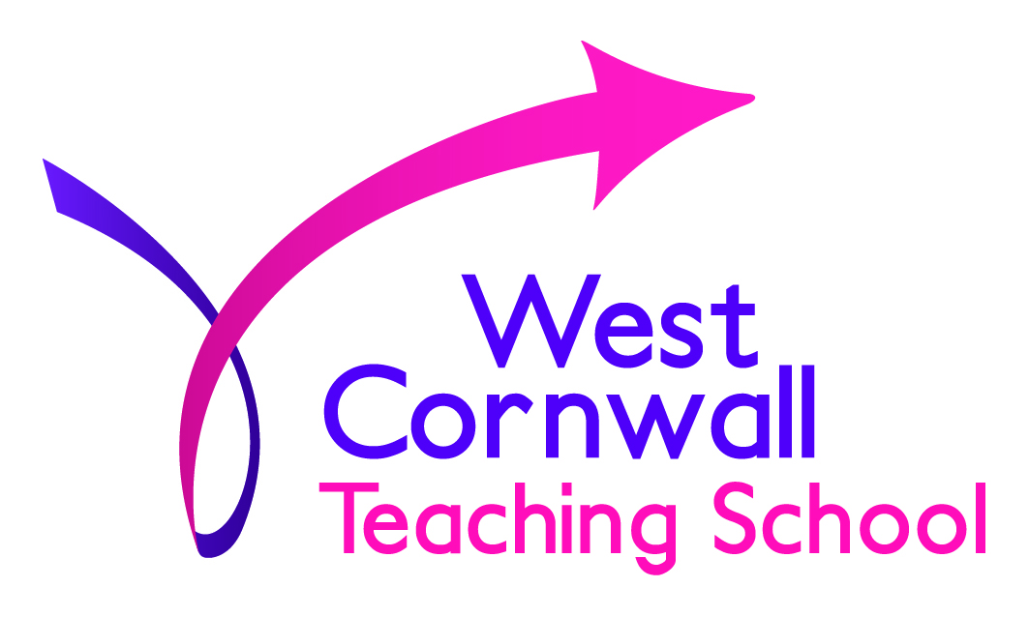

Booking Form (please return ntostdevine@parc-eglos.cornwall.sch.uk)
‘Achieving Mastery’ by Ian Taylor
Course title:
Parc Eglos School – Monday 4th September 2017 from 9.15am
Location and date

First name:

Last name:

Job title:

Email: (required)

Organisation name:

Do you have any access requirements? e.g. due to hearing or visual impairment, wheelchair access etc. (required)

Do you have any special dietary requirements?

In the event of last minute change of venue or course cancellation, please provide delegate contact details.

Telephone (preferably mobile): (required)
Email: (required)

Invoice details
Please provide the details and contact information of the person who will pay the invoice. Please note, we will normally send an invoice at the end of a course.

Name and address for invoice

Email

Telephone

Purchase order number (if relevant)

Cancellations
We operate the following cancellation policy.
For all cancellations made within the last fortnight and up to two days before a course, 50% of the total course charge will be made.
For all cancellations the day before a course or on the day, the total course charge will be made.

